Outdoor Wireless 11ac Device
Model: GNT-CP1500

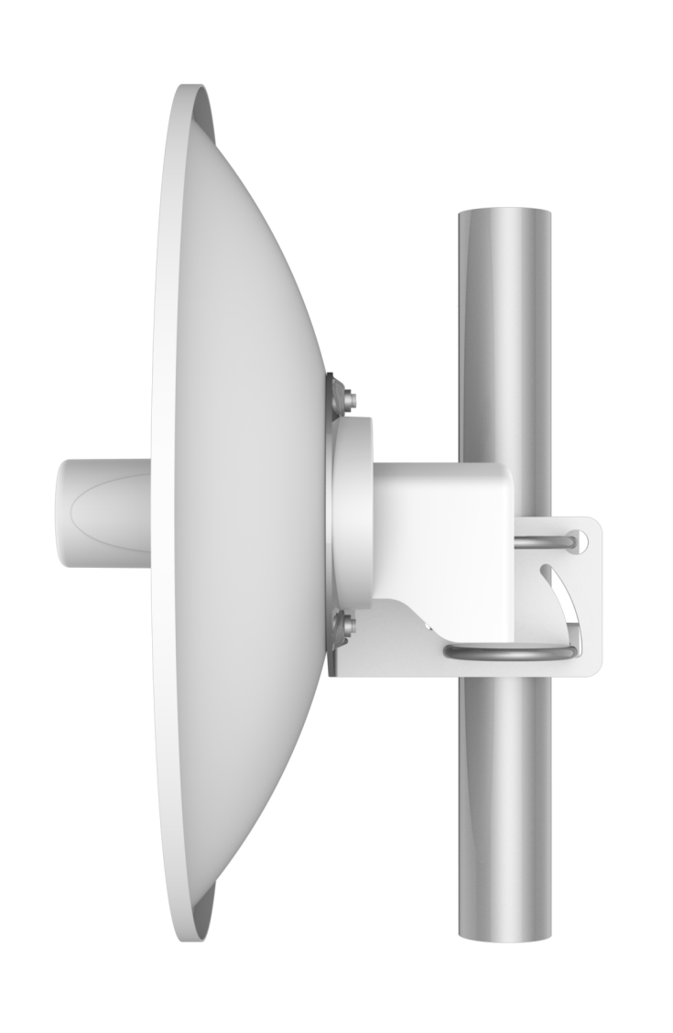
Short Specification
GNT-CP1500 is a high-performance, high-speed outdoor long-distance wireless bridge with characteristics such as long transmission distance, strong penetration ability, and strong anti-interference ability.

Product Highlight:
- Support non-standard frequency points, spread spectrum to 4.9-6.1GHz
- Integrated 23dBi dual polarization dish antenna, up to 15 kilometers
- TDMA Intelligent Dynamic Polling Protocol
- Support 5, 10MHz narrowband operating bandwidth
- Supporting IPv6, ATPC, VLAN

Hardware Specification
Model | GNT-CP1500
CPU | QCA9563+QCA9882+QCA8334
Flash | SPI NOR 16MB
DDR2 | 64MB
5G Band | 5.150GHz～5.850GHz
5G WIFI Protocol | 802.11 a / n /ac
Maximum rate | 900Mbps
Antenna | Integrated 23dBi dual polarization dish antenna
5G Tx power | 802.11a | 54M | 23±2dBm | 6M | 26±2dBm
5G Tx power | 802.11n HT20 | MCS7 | 22±2dBm | MCS0 | 26±2dBm
5G Tx power | 802.11n HT40 | MCS7 | 22±2dBm | MCS0 | 26±2dBm
5G Tx power | 802.11ac VHT20 | MCS9 | 21±2dBm | MCS0 | 26±2dBm
5G Receiving sensitivity | 802.11ac VHT40 | MCS9 | 21±2dBm | MCS0 | 26±2dBm
5G Receiving sensitivity | 802.11ac VHT80 | MCS9 | 21±2dBm | MCS0 | 26±2dBm
5G Receiving sensitivity | 802.11a | 54M | -75dBm | 6M | -92dBm
5G Receiving sensitivity | 802.11n HT20 | MCS7 | -72dBm | MCS0 | -90dBm
5G EVM | 802.11a_54M: ≤-25 dB；802.11n_MCS7: ≤-28 dB；802.11AC_MCS9:≤-32dB
frequency deviation（ppm） | ±20ppm
Port (WAN) | 1*10/100/1000M WAN, support 802.3af 48V POE
Port（LAN） | 1*10/100/1000M LAN
Supply | 802.3af，DC 12~24V
Consumption | <10W
Reset Button | Long press for 6-10 seconds to restore factory default configuration
LED | SYS, WAN, LAN, signal*5
Size | 374.2mm*201mm
Weight | 2.6KG
Environment | Operating temperature: -40°C to 70°C  Storage temperature: -40°C to 70°C；humidity：5％～95％（No condensation）
IP grade | IP65
ESD | Air +/-8K，Contact +/-6K
Surge protection | Common-Mode: 4K，Differential-Mode: 2K

Firmware Specification
Working mode | Access Point (Automatic WDS), Access Point (TDMA3), Site (WDS/TDMA3), Site (ARPNAT)
Wireless | Intelligent dynamic polling, automatic channel selection, automatic modulation mode selection, automatic transmission power control (ATPC)
Wireless Safety | WPA/WPA2 personal encryption, WPA/WPA2 enterprise encryption, WACL, user isolation
Wireless QoS | TDMA implements 4 queue priority
Network mode | IPv4 IPv6
VLAN | Support VLAN and VLAN transparent transmission
WAN protocol | Static IP，DHCP client
Service | DHCP service, SNMP service, NTP client, route tracking, ping watchdog
Management | HTTP(S) GUI, SSH, SNMP read, WNMS, Telnet
Built Tool | Site survey, connection testing, antenna calibration

Antenna Specification
V Pol |  | H Pol
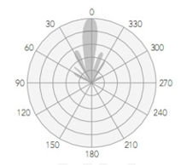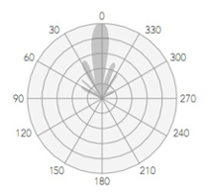

Internal antenna
Frequency range | 5180 ~5850 MHz
Gain | 23 dBi
Polarization | Dual linear
Cross-pol Isolation | 30 dB
VSWR | <1.8
Azimuth beamwidth(H pol) | 6 °
Azimuth beamwidth(V pol） | 6 °

Interface
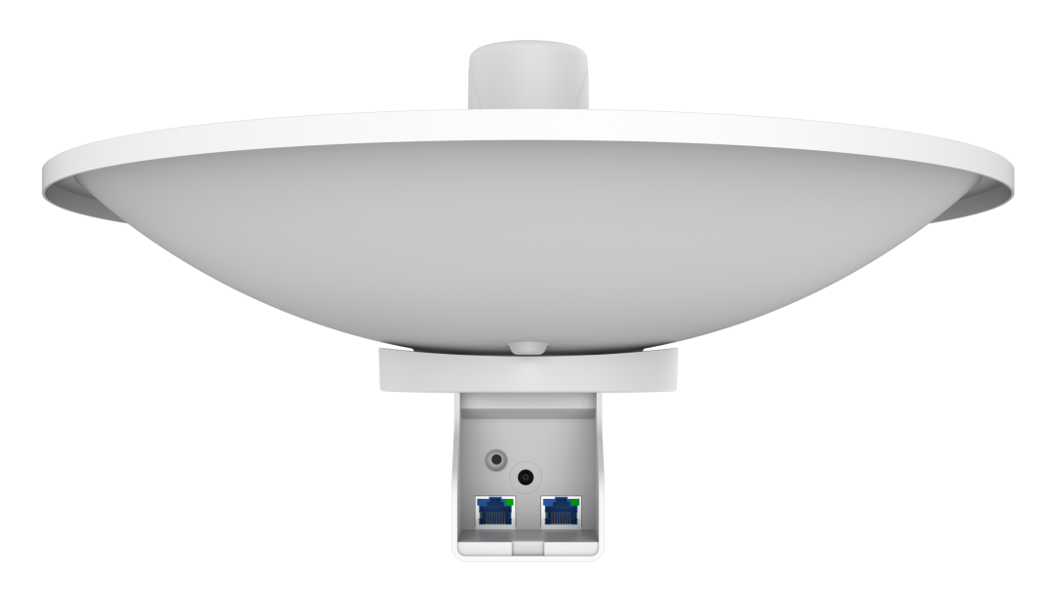

Dimension
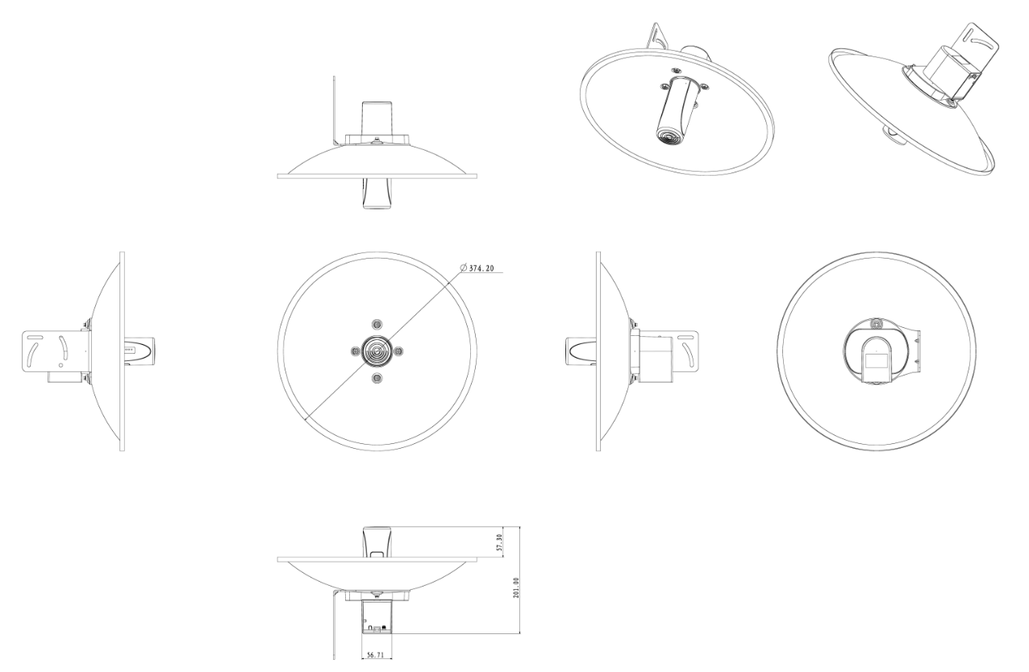
Packing List
CPE | 1
Dish antenna | 1
PoE adapter | 1
Rack kit | 1
Gift Box | 1

