1200Mbps Dual Band Wall Mount Wireless AP
Model: GNT-AP670

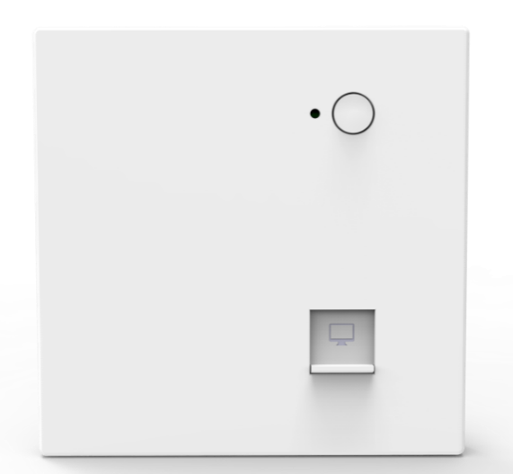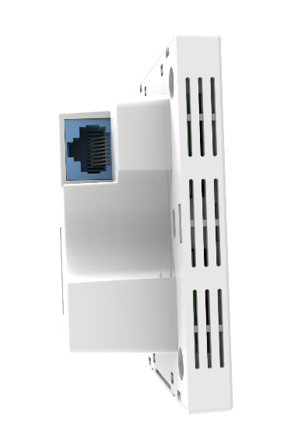

Description:
GNT-AP670 is an 11ac dual band wall mount style wireless access point upgrade to the latest wireless-AC technology, fast data rate (900Mbps in 5G and 300Mbps in 2.4GHz) and dual band allowing content to download faster, large video or music files to sync more quickly and stream seamlessly. Embed PoE, work in hotel, school, hospital mainly for a stable wireless networking. Then work with Access Controller System and cloud management system, easy in central configuration, meet with different advertisement and multiple authentication requirement, professional and cost effectively in large area Wi-Fi solution

Wireless AC Technology, more users
The GNT-AP670 AC dual band wall mount Wireless Access Point with Gigabit WAN port, offers AC technology 1200Mbps data rate for seamless/smoother video and music streaming. More users including computers, Internet-ready TVs, game consoles, and other Wi-Fi devices can access into this wireless networking

Support 802.11kvr Seamless Roaming
It support 802.11kvr seamless roaming, user will enjoy the freely networking without any suspend even the wireless signal switch from this AP to another AP.

Enterprise Level Security
GNT-AP670 support 64/128-bit WPA / WPA2, WPA-PSK/ WPA2-PSK encryption and RADIUS 802.1x security, very simple to configure, then system auto match the best encryption to guarantee the whole data and network safety.

Dual Band, 5G Priority, Less Interference
Double your network bandwidth with Dual-Band AC(2.4G and 5G) and 5G priority, designed to help avoid interference and maximize throughput. You can browse web pages, handle mails and chat over 2.4G while enjoying large-free HD multimedia and online gaming over 5G without worrying about interference.

Build in Wi-Fi Channel Analysis Tool for best channel
Build in Smart Channel Analysis Tool, help to select the less Wi-Fi Interference channels, ensure the stability wireless signal.

Power over Ethernet
GNT-AP670 has integrated IEEE 802.3af standard Power over Ethernet (PoE), for easy installation and lower cost. So it can be installed in areas where power outlets are not readily available, eliminating the mess of altering existing network infrastructure.

Multiple application scene and Central management
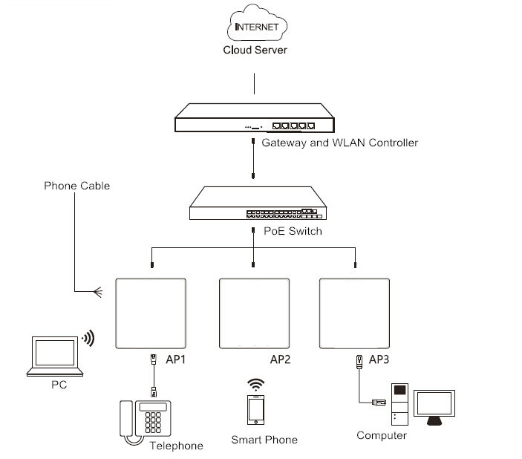
Work with soft or hardware AC controller and PoE switch, plug and play, then allow administrator to manage it in centrally and remotely, suit for hotel, school, hospital, provide stable wireless access, promote advertisement and collect user information for second time sales.

Work with multiple function smart router, plug and play, easy to provide high security dual band wireless access for end users and gigabit Ethernet for IPTV. Then all cable is embedded in the wall, safety, tidy and perfectly comply with home decoration.
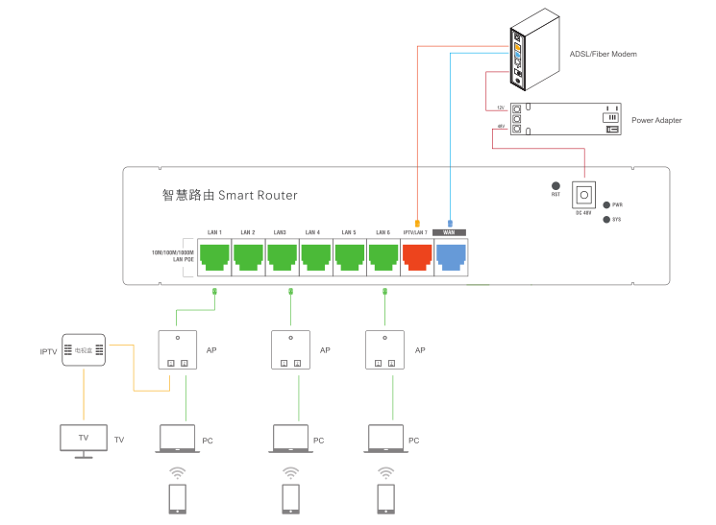
SPEC:
HARDWARE FEATURES
Chipset | MT7628DAN+MT7613BEN
Flash | 8M Flash
DDR | 64M DDR
Interface | 1*10/100Mbps WAN port  1*10/100Mbps LAN ports  1*WiFi Switch On/Off button  1*Reset button
Power Supply | 48V PoE, IEEE 802.3af standard
Maxi power consumption | < 6W
Dimensions (W X D X H) | 87*86*35.8mm
Antenna Type | On board WiFi antenna  2.4G: 3dBi omni antenna  5.8G: 5dBi omni antenna

WIRELESS FEATURES
Wireless Standards | IEEE 802.11ac/n/a 5GHz;  IEEE 802.11n/g/b 2.4GHz
Frequency | 5GHz : 5.150GHz～5.850GHz  2.4GHz: 2.4GHz – 2.484GHz
Signal Rate | 5GHz: Up to 900Mbps;  2.4GHz: Up to 300Mbps
RF Power (2.4GHz) | 802.11b | 11M |  | 17±2dBm |  | 1M | 19±2dBm
RF Power (2.4GHz) | 802.11g | 54M |  | 16±2dBm |  | 6M | 18±2dBm
RF Power (2.4GHz) | 802.11n HT20 | MCS7 |  | 15±2dBm |  | MCS0 | 17±2dBm
RF Power (2.4GHz) | 802.11n HT40 | MCS7 |  | 14±2dBm |  | MCS0 | 16±2dBm
RF Power (5GHz) | 802.11a | 54M |  | 16±2dBm |  | 6M | 18±2dBm
RF Power (5GHz) | 802.11n HT20 | MCS7 |  | 15±2dBm |  | MCS0 | 17±2dBm
RF Power (5GHz) | 802.11n HT40 | MCS7 |  | 14±2dBm |  | MCS0 | 16±2dBm
RF Power (5GHz) | 802.11ac HT80 | MCS9 |  | 13±2dBm |  | MCS0 | 15±2dBm
Receive Sensitivity (2.4GHz) | 802.11b |  | 11M |  | -82dBm | 1M |  | -94dBm
Receive Sensitivity (2.4GHz) | 802.11g |  | 54M |  | -72dBm | 6M |  | -90dBm
Receive Sensitivity (2.4GHz) | 802.11n HT20 |  | MCS7 |  | -70dBm | MCS0 |  | -88dBm
Receive Sensitivity (2.4GHz) | 802.11n HT40 |  | MCS7 |  | -68dBm | MCS0 |  | -86dBm
Receive Sensitivity (5GHz) | 802.11a |  | 54M |  | -72dBm | 6M |  | -90dBm
Receive Sensitivity (5GHz) | 802.11n HT20 |  | MCS7 |  | -70dBm | MCS0 |  | -88dBm
Receive Sensitivity (5GHz) | 802.11n HT40 |  | MCS7 |  | -68dBm | MCS0 |  | -86dBm
Receive Sensitivity (5GHz) | 802.11ac HT80 |  | MCS9 |  | -58dBm | MCS0 |  | -82dBm
Wireless | Auto-Channel selection
Wireless | Distance Control (802.1x Ack timeout)
Wireless | Multiple SSID (4 SSID for 2.4G, 4 SSID for 5.8G)
Wireless | BSSID
EVM | 2.4G: 802.11b: ≤-10 dB; 802.11g: ≤-25dB; 802.11n: ≤-28 dB  5G: 802.11a: ≤-25 dB; 802.11n: ≤-28 dB; 802.11ac: ≤-32 dB
PPM | ±20ppm
Max Access Users | 128
Operation Mode | Wireless AP, Gateway, Wi-Fi Repeater
Wireless Security | OPEN、WPA、WPA2、WPA-PSK、WPA2-PSK
ESD - I | Air discharge:±4KV
Surge | Common-mode: ±2KV
LED Status | SYS

Management
System Settings | Web-based configuration / Software AC controller and Hardware AC controller management
Firmware Upgrade | Upgrade firmware via web browser or AC controller
Administration | Admin Password can be configured
System monitoring | Watch dog, Status in hand , useful statistic and Event log
Logs | Supports local logs, logs host, logs file export
Reset | Reset or factory defaults
Backup | Restore settings & configuration of the device to local file, Scheduled reboot

OTHERS
Package Contents | 1200Mbps Dual Band wireless access point  Quick Installation Guide  Setting Accessory
System Requirements | Microsoft Windows 98SE, NT, 2000, XP, Vista™ or Windows 7, Windows 8, Windows 10, MAC OS, NetWare, UNIX or Linux
Environment | Operating Temperature: -20~55 ℃  Extreme Temperature: -40~70 ℃  Storage Temperature: -40~70 ℃  Humidity: 5%~95% non-condensing

Case Design:
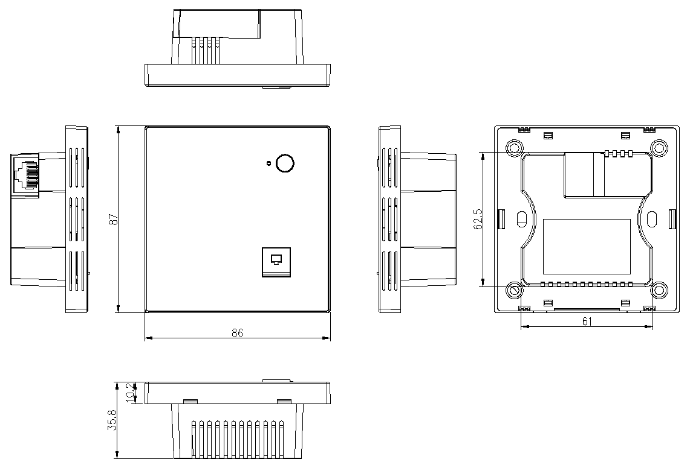

Packing:
- Product Sticker:
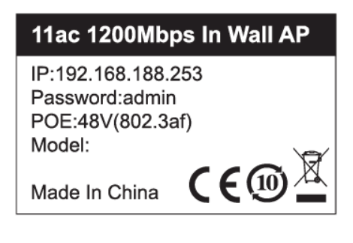
- Packing Box with Inner Card:
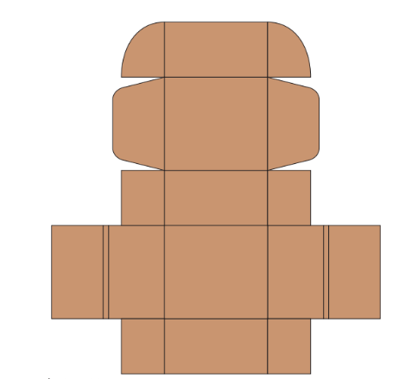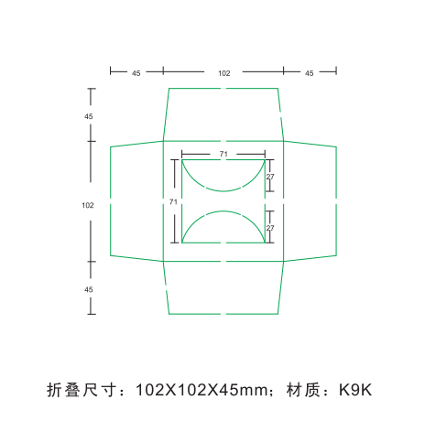
- Carton box:
