11ax 3000Mbps Inwall Wireless AP

Model: GNT-AP818

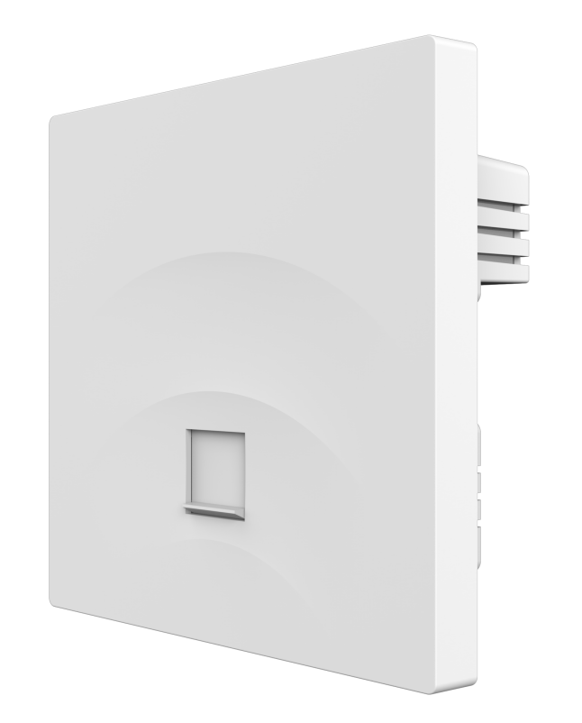

Short Specification

It is a high-performance, high-speed indoor 11ax panel AP that can provide 2.4G and 5.8GHz dual band wireless services, providing a cleaner wireless environment and more stable wireless access.

Key Features:

- Simultaneously running 2.4GHz (574Mbps) and 5GHz (1201Mbps) to achieve maximum wireless throughput
- Support hardware watchdog function, automatic recovery of abnormal devices, maintenance free
- The heat sink is treated with a special surface coating, resulting in a more ideal heat dissipation effect
- Supports 48V PoE

Hardware Specification
CPU | MT7981B+MT7976CN+RTL8211FS
Flash | Nand 128MB
DDR3L | 256MB
2.4G Frequency | 2.4GHz ~ 2.484GHz
2.4G Protocol | 802.11 b / g / n / ax
5G Frequency | 5.150GHz～5.850GHz
5G Protocol | 802.11 a / n / ac / ax
Antenna | Dual band 2*1.7dBi
Data Rate | 5G: 2402Mbps 2.4G:574Mbps
2.4G TX Power | 802.11b | 11M | 18±2dBm | 1M | 20±2dBm
2.4G TX Power | 802.11g | 54M | 16±2dBm | 6M | 18±2dBm
2.4G TX Power | 802.11n HT20 | MCS7 | 15±2dBm | MCS0 | 17±2dBm
2.4G TX Power | 802.11n HT40 | MCS7 | 15±2dBm | MCS0 | 17±2dBm
2.4G TX Power | 802.11ax HT20 | MCS11 | 13±2dBm | MCS0 | 15±2dBm
2.4G TX Power | 802.11ax HT40 | MCS11 | 13±2dBm | MCS0 | 15±2dBm
5G TX Power | 802.11a | 54M | 15±2dBm | 6M | 17±2dBm
5G TX Power | 802.11n HT20 | MCS7 | 14±2dBm | MCS0 | 16±2dBm
5G TX Power | 802.11n HT40 | MCS7 | 14±2dBm | MCS0 | 16±2dBm
5G TX Power | 802.11ac HT20 | MCS7 | 13±2dBm | MCS0 | 15±2dBm
5G TX Power | 802.11ac HT40 | MCS7 | 13±2dBm | MCS0 | 15±2dBm
5G TX Power | 802.11ac HT80 | MCS9 | 13±2dBm | MCS0 | 15±2dBm
5G TX Power | 802.11ax HT20 | MCS11 | 12±2dBm | MCS0 | 14±2dBm
5G TX Power | 802.11ax HT40 | MCS11 | 12±2dBm | MCS0 | 14±2dBm
5G TX Power | 802.11ax HT80 | MCS11 | 12±2dBm | MCS0 | 14±2dBm
5G TX Power | 802.11ax HT160 | MCS11 | 12±2dBm | MCS0 | 14±2dBm
2.4G Receiving Sensitivity | 802.11b | 11M | -83dBm | 1M | -90dBm
2.4G Receiving Sensitivity | 802.11g | 54M | -70dBm | 6M | -84dBm
2.4G Receiving Sensitivity | 802.11n HT20 | MCS7 | -68dBm | MCS0 | -83dBm
2.4G Receiving Sensitivity | 802.11n HT40 | MCS7 | -66dBm | MCS0 | -83dBm
2.4G Receiving Sensitivity | 802.11ax HT20 | MCS11 | -56dBm | MCS0 | -83dBm
2.4G Receiving Sensitivity | 802.11ax HTs40 | MCS11 | -53dBm | MCS0 | -83dBm
5G Receiving Sensitivity | 802.11a | 54M | -70dBm | 6M | -83dBm
5G Receiving Sensitivity | 802.11n HT20 | MCS7 | -67dBm | MCS0 | -83dBm
5G Receiving Sensitivity | 802.11n HT40 | MCS7 | -64dBm | MCS0 | -83dBm

5G Receiving Sensitivity | 802.11ac HT20 | MCS7 | -58dBm | MCS0 | -83dBm
5G Receiving Sensitivity | 802.11ac HT40 | MCS7 | -57dBm | MCS0 | -83dBm
5G Receiving Sensitivity | 802.11ac HT80 | MCS9 | -56dBm | MCS0 | -85dBm
5G Receiving Sensitivity | 802.11ax HT20 | MCS11 | -57dBm | MCS0 | -83dBm
5G Receiving Sensitivity | 802.11ax HT40 | MCS11 | -56dBm | MCS0 | -83dBm
5G Receiving Sensitivity | 802.11ax HT80 | MCS11 | -53dBm | MCS0 | -82dBm
5G Receiving Sensitivity | 802.11ax HT160 | MCS11 | -51dBm | MCS0 | -88dBm
2.4G EVM | 802.11b: ≤-10 dB ；802.11g: ≤-25 dB ；802.11n: ≤-28dB ;802.11ax: ≤-35 dB
5G EVM | 802.11a: ≤-25 dB ；802.11n: ≤-28 dB ；802.11ac: ≤-32 dB; 802.11ax: ≤-35 dB
ppm | ±20ppm
WAN | 1*10/100/1000M WAN, support 48V POE
LAN | 1*10/100/1000M LAN
POE | 802.3af
Reset | Reset to factory settings by pressing 6-10 seconds
Indicators | SYS
Max Power Consumption | <12W
ESD | Air:±8K, Touch:±6K
Electrical Surge | Common Mode: 1K, Differential Mode: 0.5K
Size | 86mm*86mm*38.8mm
Weight | 0.15kg
Temperature | Working: -10°C to 40°C；Storage: -40°C to 70°C；Humidity: 5％～95％(Non-Condensing)

Firmware Specification
Working Mode | AP(FAT/ FIT)
Wireless Functions | Multiple SSID functions: 2.4GHz: 4; 5.8GHz: 4.
Wireless Functions | Support SSID hidden
Wireless Functions | Support 5G Prior for a faster Ethernet.
Wireless Functions | Wireless Security: OPEN, WPA/WPA2PSK-TKIPAES, WPA3PSK-TKIPAES
Wireless Functions | Support MAC filter
Wireless Functions | Support Wi-Fi time on/off to save energy
Wireless Functions | Support client isolation to improve the wireless stability
Wireless Functions | Support RF power adjustable, adjust the RF power based on environment.
Wireless Functions | QoS: WMM

 | Support user quantity limited, Max 64 users to access each band.
Networking Function | VLAN settings
Networking Function | Cloud access support in FAT mode
Device Management | Back-up the configuration
Device Management | Restore the configuration
Device Management | Reset to factory default
Device Management | Reboot the device: including time reboot or reboot immediately
Device Management | Admin management password modify
Device Management | Firmware upgrade
Device Management | System log
Device Management | Support firmware GUI web management, AC controller management, remote management and cloud management

Interface


Dimension
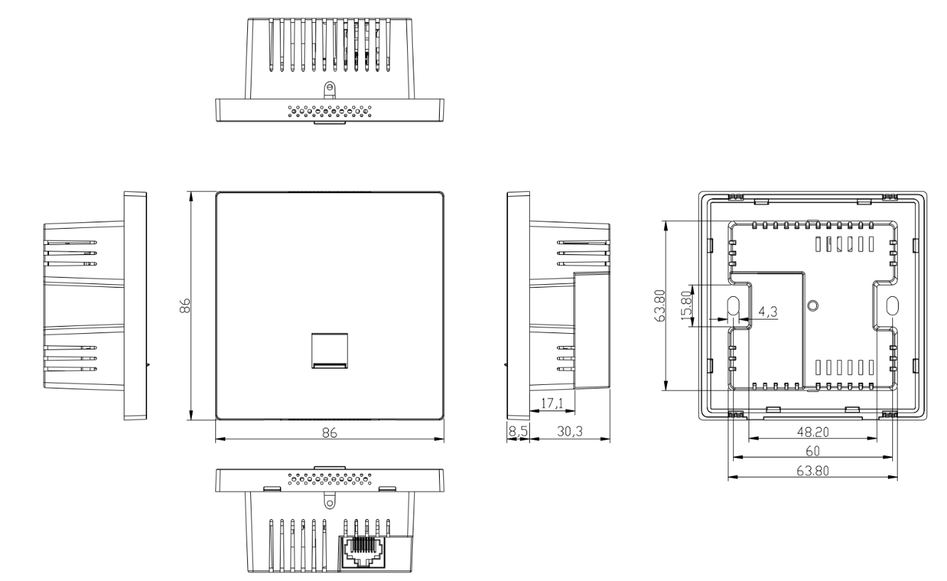

Packing List

AP | 1
Screw | 2
Gift Box | 1

