11ax 1800Mbps Ceiling Wireless AP
Model: GNT-AP690

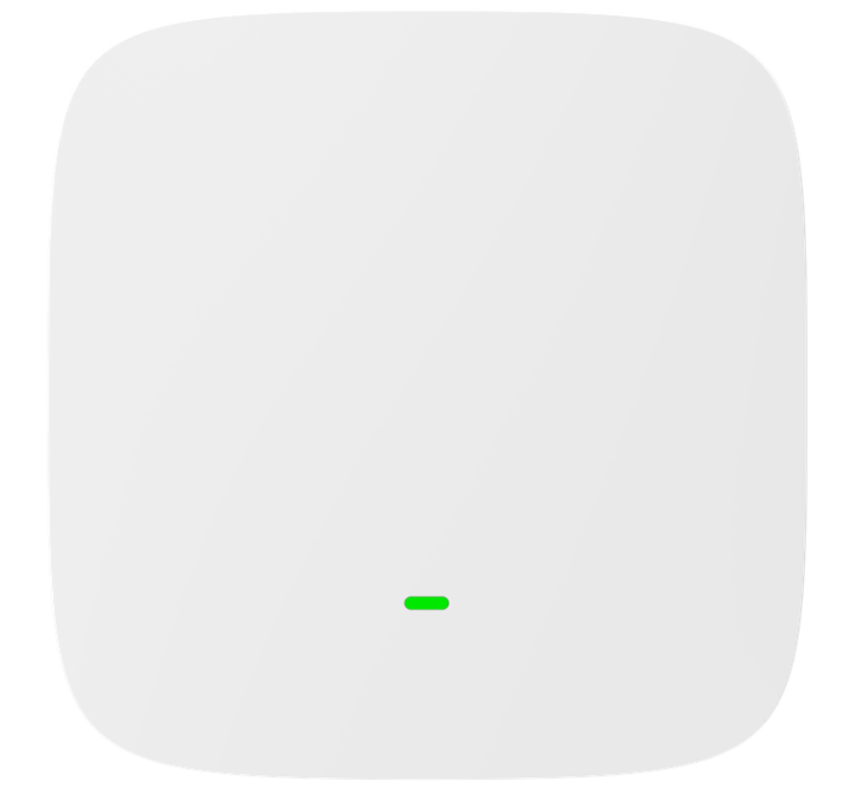

Short Specification
GNT-AP690 is a high-performance, high-speed indoor 11ax dual-band ceiling AP. 2.4G provides a maximum access rate of 574Mbps, and 5G provides a maximum access rate of 1201Mbps.

Key Features
- It has better transmission quality, higher transmission rate, and a maximum concurrent speed of 1775Mbps for the entire machine.
- Support hardware watchdog function, automatic recovery of abnormal devices, no maintenance required.
- Elegant appearance design, hidden port housing, and beautiful wiring.
- Both 48V PoE and DC 12V power supply modes are supported.

Hardware Specification
Model | GNT-AP690
CPU | MT7621AT+MT7905N+MT7975DN
Flash | SPI NOR 16MB
DDR3 | 256M
2.4G Band | 2.4GHz ~ 2.484GHz
2.4G WIFI protocol | 802.11 b / g / n /ax
5G Band | 5.150GHz～5.850GHz
5G WIFI protocol | 802.11a/n/ac/ax
2.4G Antenna | Built in two 2.4G antennas, each with a gain of 4.6dBi
5G Antenna | Built in two 5G antennas, each with a gain of 4dBi
Maximum rate | 2.4G up to 574Mbps, 5G up to 1201Mbps
2.4G Tx power | 802.11b | 11M | 22±2dBm | 1M | 22±2dBm
2.4G Tx power | 802.11g | 54M | 19±2dBm | 6M | 20±2dBm
2.4G Tx power | 802.11n HT20 | MCS7 | 18±2dBm | MCS0 | 20±2dBm
2.4G Tx power | 802.11n HT40 | MCS7 | 18±2dBm | MCS0 | 20±2dBm
2.4G Tx power | 802.11ax HT20 | MCS11 | 15±2dBm | MCS0 | 20±2dBm
2.4G Tx power | 802.11ax HT40 | MCS11 | 15±2dBm | MCS0 | 20±2dBm
5G Tx power | 802.11a | 54M | 18±2dBm | 6M | 20±2dBm
5G Tx power | 802.11n HT20 | MCS7 | 17±2dBm | MCS0 | 19±2dBm
5G Tx power | 802.11n HT40 | MCS7 | 17±2dBm | MCS0 | 19±2dBm
5G Tx power | 802.11ac HT20 | MCS7 | 16±2dBm | MCS0 | 19±2dBm
5G Tx power | 802.11ac HT40 | MCS7 | 16±2dBm | MCS0 | 19±2dBm
5G Tx power | 802.11ac HT80 | MCS9 | 16±2dBm | MCS0 | 19±2dBm
5G Tx power | 802.11ax HT20 | MCS11 | 15±2dBm | MCS0 | 19±2dBm
5G Tx power | 802.11ax HT40 | MCS11 | 15±2dBm | MCS0 | 19±2dBm
5G Tx power | 802.11ax HT80 | MCS11 | 15±2dBm | MCS0 | 19±2dBm
2.4G Receiving sensitivity | 802.11b | 11M | -82dBm | 1M | -88dBm
2.4G Receiving sensitivity | 802.11g | 54M | -72dBm | 6M | -88dBm
2.4G Receiving sensitivity | 802.11n HT20 | MCS7 | -70dBm | MCS0 | -88dBm
2.4G Receiving sensitivity | 802.11n HT40 | MCS7 | -68dBm | MCS0 | -85dBm

 | 802.11ax HT20 | MCS11 | -60dBm | MCS0 | -88dBm
 | 802.11ax HT40 | MCS11 | -56dBm | MCS0 | -85dBm
5G Receiving sensitivity | 802.11a | 54M | -72dBm | 6M | -89dBm
5G Receiving sensitivity | 802.11n HT20 | MCS7 | -71dBm | MCS0 | -89dBm
5G Receiving sensitivity | 802.11n HT40 | MCS7 | -68dBm | MCS0 | -86dBm
5G Receiving sensitivity | 802.11ac HT20 | MCS7 | -66dBm | MCS0 | -89dBm
5G Receiving sensitivity | 802.11ac HT40 | MCS7 | -60dBm | MCS0 | -86dBm
5G Receiving sensitivity | 802.11ac HT80 | MCS9 | -57dBm | MCS0 | -83dBm
5G Receiving sensitivity | 802.11ax HT20 | MCS11 | -58dBm | MCS0 | -88dBm
5G Receiving sensitivity | 802.11ax HT40 | MCS11 | -55dBm | MCS0 | -85dBm
5G Receiving sensitivity | 802.11ax HT80 | MCS11 | -52dBm | MCS0 | -82dBm
2.4G EVM | 802.11b:≤-10 dB；802.11g:≤-25 dB；802.11n:≤-28dB ; 802.11ax: ≤-35 dB
5G EVM | 802.11a:≤-25 dB； 802.11n:≤-28 dB；802.11ac:≤-32 dB ; 802.11ax:≤-35 dB
frequency deviation（ppm） | ±20ppm
Port (WAN) | 1*10/100/1000M，support 48V POE
Port（LAN） | 1*10/100/1000M
Reset Button | reset（Long press for 6-10 seconds to restore factory default configuration）
LED | Tricolor lamp（Three different colors represent：sys-Red，2.4G-Green，5.8G-Blue）
Supply | DC2.0 12V 1.5A，PoE 802.3af
Consumption | < 15W
Size | 186mm × 186mm ×36mm
Height | 0.4kg
Environment | Operating temperature-10°C to 40°C；Storage temperature: -40°C to 70°C；humidity：5％～95％（No condensation）
ESD | Air +/-8K， Contact +/-4K

Firmware Specification
Working Mode | Gateway, AP
Wireless Functions | Multiple SSID functions: 2.4GHz: 4; 5.8GHz: 4.
Wireless Functions | Support SSID hidden
Wireless Functions | Support seamless roaming, 802.11kvr standard.
Wireless Functions | Support 5G Prior for a faster Ethernet.
Wireless Functions | Wireless Security: Open, WPA, WPA2PSK_TKIPAES, WAP2_EAP, 802.1x
Wireless Functions | Support MAC filter
Wireless Functions | Support Wi-Fi time on/off to save energy
Wireless Functions | Support client isolation to improve the wireless stability
Wireless Functions | Support RF power adjustable, adjust the RF power based on environment.
Wireless Functions | Support user quantity limited, Max 64 users to access each band.
Networking Function | VLAN settings
Networking Function | Cloud access support in gateway mode
Device Management | Back-up the configuration
Device Management | Restore the configuration
Device Management | Reset to factory default
Device Management | Reboot the device: including time reboot or reboot immediately
Device Management | Admin management password modify
Device Management | Firmware upgrade
Device Management | System log
Device Management | Support firmware GUI web management, AC controller management, remote management and cloud management
Protocols | IPv4

Interface
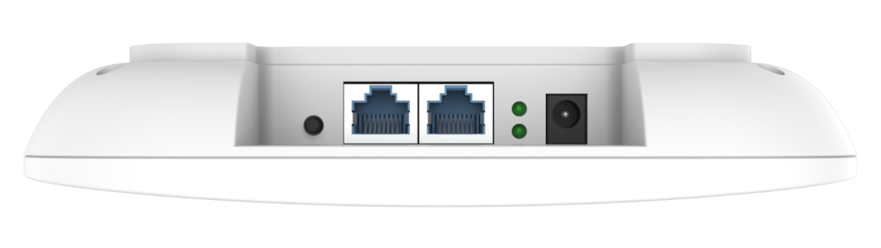

Dimension:

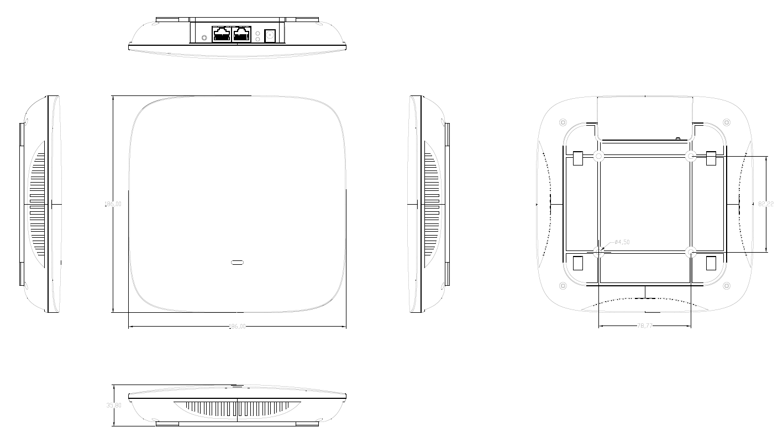

Packing List
AP | 1
Lan cable | 1
Mounting Accessories | 1
Gift Box | 1

