11ax 3000Mbps Ceiling Wireless AP
Model: GNT-AP835

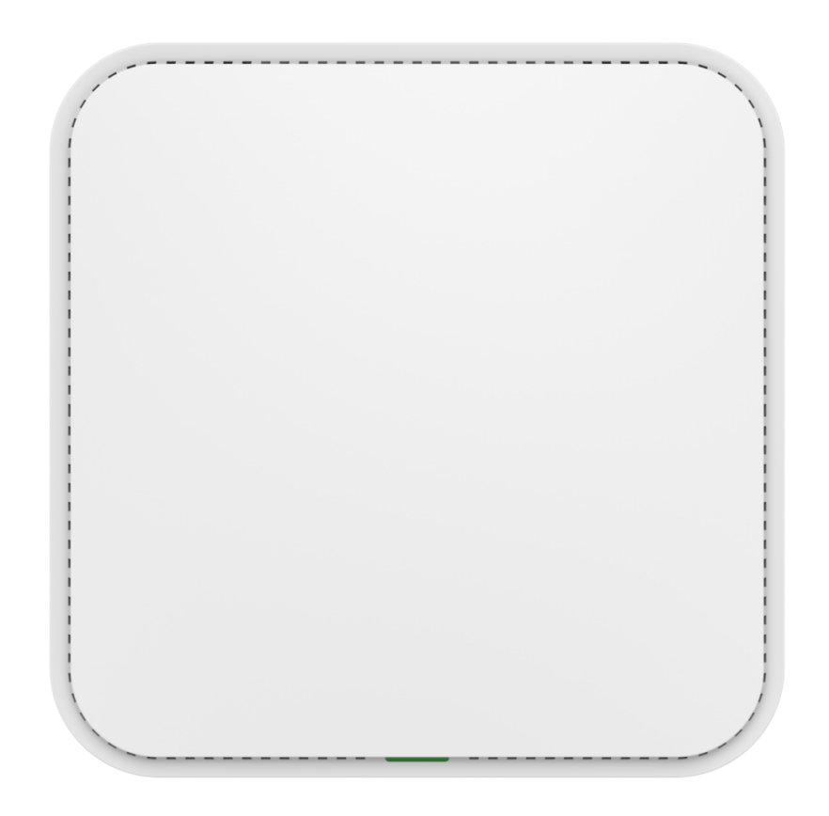

Short Specifications
GNT-AP835 is a high-performance, high-speed 11ax indoor dual-band ceiling AP that can provide 2.4G and 5.8GHz dual-band wireless services. 2.4G provides up to 574Mbps access rate, and 5G provides up to 2402Mbps access rate.

Key Features
• With better transmission quality and higher transmission rate, the overall concurrent rate can reach up to 3000Mbps.
• Support hardware watchdog function, automatic recovery of abnormal equipment, and maintenance free.
• Elegant appearance design, port concealed housing, and beautiful wiring.
• Supports two power supply modes: 48V PoE and DC 12V.

Hardware Specification
Model | GNT-AP835
CPU | MT7981B+MT7976CN+7531AE
Flash | SPI NOR 16MB
DDR3 | 256M
2.4G Frequency | 2.4GHz ~ 2.484GHz
2.4G WIFI protocol | 802.11 b / g / n / ax
5G Frequency | 5.150GHz～5.850GHz
5G WIFI protocol | 802.11 a / n / ac / ax
2.4G Antenna | 2*2.4G， gain：4.6dBi
5G Antenna | 2*5G， gain：4dBi
Wireless data rate | 2.4G: 574Mbps，5G: 2402Mbps
2.4G Power | 802.11b | 11M | 22±2dBm | 1M | 22±2dBm
2.4G Power | 802.11g | 54M | 19±2dBm | 6M | 21±2dBm
2.4G Power | 802.11n HT20 | MCS7 | 18±2dBm | MCS0 | 20±2dBm
2.4G Power | 802.11n HT40 | MCS7 | 18±2dBm | MCS0 | 20±2dBm
2.4G Power | 802.11ax HT20 | MCS11 | 16±2dBm | MCS0 | 20±2dBm
2.4G Power | 802.11ax HT40 | MCS11 | 16±2dBm | MCS0 | 20±2dBm
5G Power | 802.11a | 54M | 19±2dBm | 6M | 21±2dBm
5G Power | 802.11n HT20 | MCS7 | 18±2dBm | MCS0 | 20±2dBm
5G Power | 802.11n HT40 | MCS7 | 18±2dBm | MCS0 | 20±2dBm
5G Power | 802.11ac HT20 | MCS7 | 17±2dBm | MCS0 | 20±2dBm
5G Power | 802.11ac HT40 | MCS7 | 17±2dBm | MCS0 | 20±2dBm
5G Power | 802.11ac HT80 | MCS9 | 17±2dBm | MCS0 | 19±2dBm
5G Power | 802.11ax HT20 | MCS11 | 16±2dBm | MCS0 | 20±2dBm
5G Power | 802.11ax HT40 | MCS11 | 16±2dBm | MCS0 | 20±2dBm
5G Power | 802.11ax HT80 | MCS11 | 16±2dBm | MCS0 | 19±2dBm
5G Power | 802.11ax HT160 | MCS11 | 14±2dBm | MCS0 | 18±2dBm
2.4G Receive Sensitivity | 802.11b | 11M | -87dBm | 1M | -96dBm
2.4G Receive Sensitivity | 802.11g | 54M | -75dBm | 6M | -93dBm
2.4G Receive Sensitivity | 802.11n HT20 | MCS7 | -73dBm | MCS0 | -92dBm
2.4G Receive Sensitivity | 802.11n HT40 | MCS7 | -70dBm | MCS0 | -89dBm
2.4G Receive Sensitivity | 802.11ax HT20 | MCS11 | -64dBm | MCS0 | -92dBm

 | 802.11ax HT40 | MCS11 | -61dBm | MCS0 | -89dBm
5G Receive Sensitivity | 802.11a | 54M | -74dBm | 6M | -92dBm
5G Receive Sensitivity | 802.11n HT20 | MCS7 | -73dBm | MCS0 | -90dBm
5G Receive Sensitivity | 802.11n HT40 | MCS7 | -70dBm | MCS0 | -87dBm
5G Receive Sensitivity | 802.11ac HT20 | MCS7 | -67dBm | MCS0 | -91dBm
5G Receive Sensitivity | 802.11ac HT40 | MCS7 | -63dBm | MCS0 | -88dBm
5G Receive Sensitivity | 802.11ac HT80 | MCS9 | -60dBm | MCS0 | -84dBm
5G Receive Sensitivity | 802.11ax HT20 | MCS11 | -62dBm | MCS0 | -91dBm
5G Receive Sensitivity | 802.11ax HT40 | MCS11 | -59dBm | MCS0 | -89dBm
5G Receive Sensitivity | 802.11ax HT80 | MCS11 | -56dBm | MCS0 | -86dBm
5G Receive Sensitivity | 802.11ax HT160 | MCS11 | -53dBm | MCS0 | -83dBm
2.4G EVM | 802.11b:≤-10 dB；802.11g:≤-25 dB；802.11n:≤-28dB ; 802.11ax: ≤-35 dB
5G EVM | 802.11a:≤-25 dB； 802.11n:≤-28 dB；802.11ac:≤-32 dB ; 802.11ax:≤-35 dB
ppm | ±20ppm
WAN | 1个10/100/1000M WAN, support 48V POE
LAN | 1个10/100/1000M LAN
Reset | Reset*1
Indicator | Triple color(sys-red，2.4G-green，5.8G-blue)
Power | PoE 802.3af，DC2.0 12V/1.5A，
Max Power Consumption | < 15W
Size | 186mm × 186mm ×37mm
Weight | 0.55kg
Temperature | Working: -20°C to 45°C；Storage: -40°C to 70°C；Humidity: 5％～95％(Non-Condensing)
ESD | Air: +/-8K，Touch: +/-4K
Electrical Surge | Common Mode: 2K, Differential Mode: 1K

Firmware Specification
Working Mode | Gateway, AP
Wireless Functions | Multiple SSID functions: 2.4GHz: 4; 5.8GHz: 4.
Wireless Functions | Support SSID hidden
Wireless Functions | Support seamless roaming
Wireless Functions | Support 5G Prior for a faster Ethernet.

 | Wireless Security: Open, WPA, WPA2PSK_TKIPAES, WAP2_EAP, WPA3
 | Support MAC filter
 | Support Wi-Fi time on/off to save energy
 | Support client isolation to improve the wireless stability
 | Support RF power adjustable, adjust the RF power based on environment.
 | Support user quantity limited, Max 64 users to access each band.
Networking Function | VLAN settings
Networking Function | Cloud access support in gateway mode
Device Management | Back-up the configuration
Device Management | Restore the configuration
Device Management | Reset to factory default
Device Management | Reboot the device: including time reboot or reboot immediately
Device Management | Admin management password modify
Device Management | Firmware upgrade
Device Management | System log
Device Management | Support firmware GUI web management, AC controller management, remote management and cloud management
Protocols | IPv4

Interface
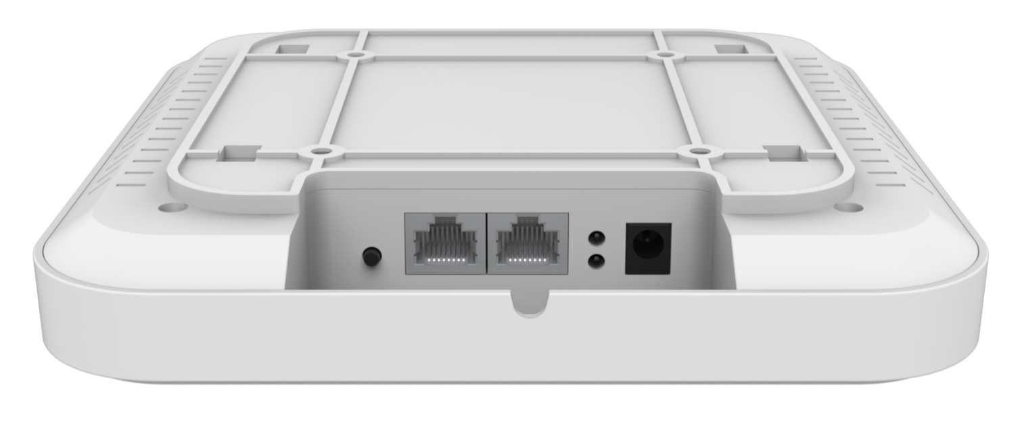

Size
