Wireless 11AC 1200Mbps Outdoor AP
Model:GNT-AP1200GF

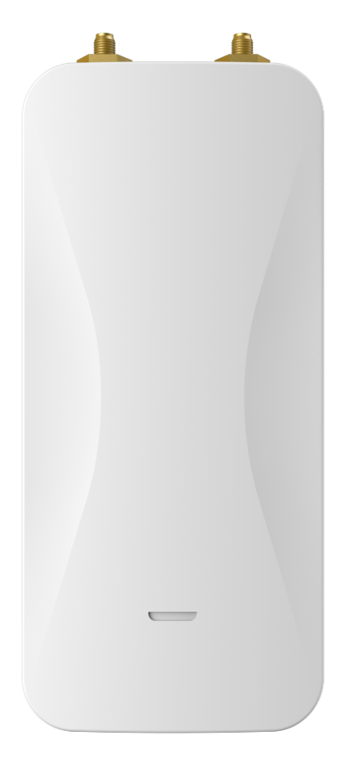

Description:
GNT-AP1200GF is an entry-level dual band 802.11ac outdoor wireless access point product that provides dual
band wireless services at 2.4GHz and 5.8GHz, with a maximum access rate of 300Mbps at 2.4GHz and
866Mbps at 5GHz.
Main Features:
- Dual frequency concurrency, with a maximum wireless concurrency rate of up to 1200Mbps.
- Supports both 48V PoE and 12V DC power supply.
- Adapted to high gain dual frequency antennas, with a wide coverage range.
- Small and stylish, easy to install.
- Low power consumption.

Hardware Spec:
Model | GNT-AP1200GF
CPU | QCA9563+ QCA9886+ QCA8337
Flash | 16MB
DDR2 | 64MB
2.4G Frequency | 2.4GHz ~ 2.484GHz
2.4G Protocol | 802.11 b / g / n
5G Frequency | 5.150GHz～5.850GHz
5G Protocol | 802.11 a / n / ac
Antenna | 2*5dBi
Data Rate | 2.4G 300 Mbps MIMO 2*2, 5G 866Mbps MIMO 2*2
2.4G TX Power | 802.11b | 11M | 23±2dBm | 1M | 24±2dBm
2.4G TX Power | 802.11g | 54M | 22±2dBm | 6M | 23±2dBm
2.4G TX Power | 802.11n HT20 | MCS7 | 20±2dBm | MCS0 | 23±2dBm
2.4G TX Power | 802.11n HT40 | MCS7 | 20±2dBm | MCS0 | 23±2dBm
5G TX Power | 802.11a | 54M | 19±2dBm | 6M | 21±2dBm
5G TX Power | 802.11n HT20 | MCS7 | 17±2dBm | MCS0 | 21±2dBm
5G TX Power | 802.11n HT40 | MCS7 | 17±2dBm | MCS0 | 21±2dBm
5G TX Power | 802.11ac HT80 | MCS9 | 16±2dBm | MCS0 | 18±2dBm
2.4G Receiving Sensitivity | 802.11b | 11M | -83dBm | 1M | -94dBm
2.4G Receiving Sensitivity | 802.11g | 54M | -70dBm | 6M | -88dBm
2.4G Receiving Sensitivity | 802.11n HT20 | MCS7 | -68dBm | MCS0 | -86dBm
2.4G Receiving Sensitivity | 802.11n HT40 | MCS7 | -66dBm | MCS0 | -84dBm
5G Receiving Sensitivity | 802.11a | 54M | -70dBm | 6M | -88dBm
5G Receiving Sensitivity | 802.11n HT20 | MCS7 | -68dBm | MCS0 | -86dBm
5G Receiving Sensitivity | 802.11n HT40 | MCS7 | -66dBm | MCS0 | -84dBm
5G Receiving Sensitivity | 802.11ac HT80 | MCS9 | -56dBm | MCS0 | -83dBm
2.4G EVM | 802.11b：≤-10 dB ；802.11g: ≤-25 dB ；802.11n: ≤-28 dB
5G EVM | 802.11a: ≤-25dB ；802.11n: ≤-28 dB ；802.11ac: ≤-32 dB
ppm | ±20ppm
WAN | 1*10/100/1000M RJ45, support 48V PoE
LAN | 1*10/100/1000M LAN
DC | 12V/1A DC

POE（WAN） | 802.3at
Reset | Reset to factory settings by pressing 6-10 seconds
Indicators | WAN, LAN, SYS, 2.4G_WiFi, 5G_WiFi.
Power | <9W
Dimension | 196mm*86mm*40mm
Weight | 0.4kg
Temperature | Working: -30°C to 55°C；Storage: -40°C to 70°C；Humidity: 5％～95％(Non-Condensing)
Protection Grade | IP65
ESD | Air:±8K, Touch:±6K
Electrical Surge | Common Mode: 6K, Differential Mode: 4K

Firmware Specification
Working Mode | Gateway, AP
Wireless Functions | Multiple SSID functions: 2.4GHz: 4; 5.8GHz: 4.
Wireless Functions | Support SSID hidden
Wireless Functions | Support seamless roaming, 802.11kvr standard.
Wireless Functions | Support 5G Prior for a faster Ethernet.
Wireless Functions | Wireless Security: Open, WPA, WPA2PSK_TKIPAES, WAP2_EAP, 802.1x
Wireless Functions | Support MAC filter
Wireless Functions | Support Wi-Fi time on/off to save energy
Wireless Functions | Support client isolation to improve the wireless stability
Wireless Functions | Support RF power adjustable, adjust the RF power based on environment.
Wireless Functions | Support user quantity limited, Max 64 users to access each band.
Networking Function | VLAN settings
Networking Function | Cloud access support in gateway mode
Device Management | Back-up the configuration
Device Management | Restore the configuration
Device Management | Reset to factory default
Device Management | Reboot the device: including time reboot or reboot immediately
Device Management | Admin management password modify
Device Management | Firmware upgrade

 | System log
 | Support firmware GUI web management, AC controller management, remote management and cloud management
Protocols | IPv4

Interface:
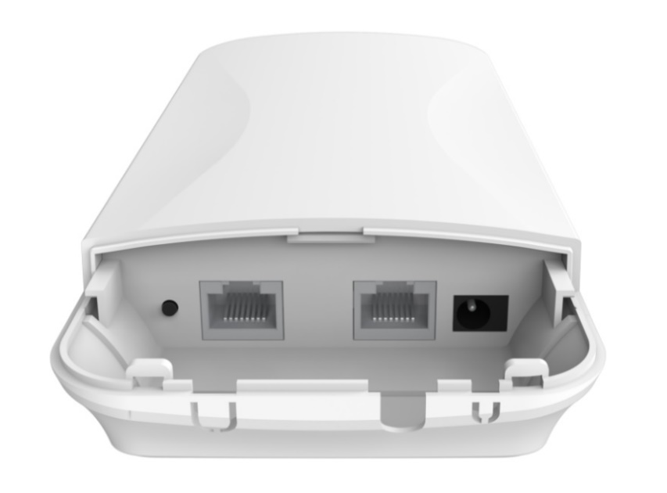
Size:
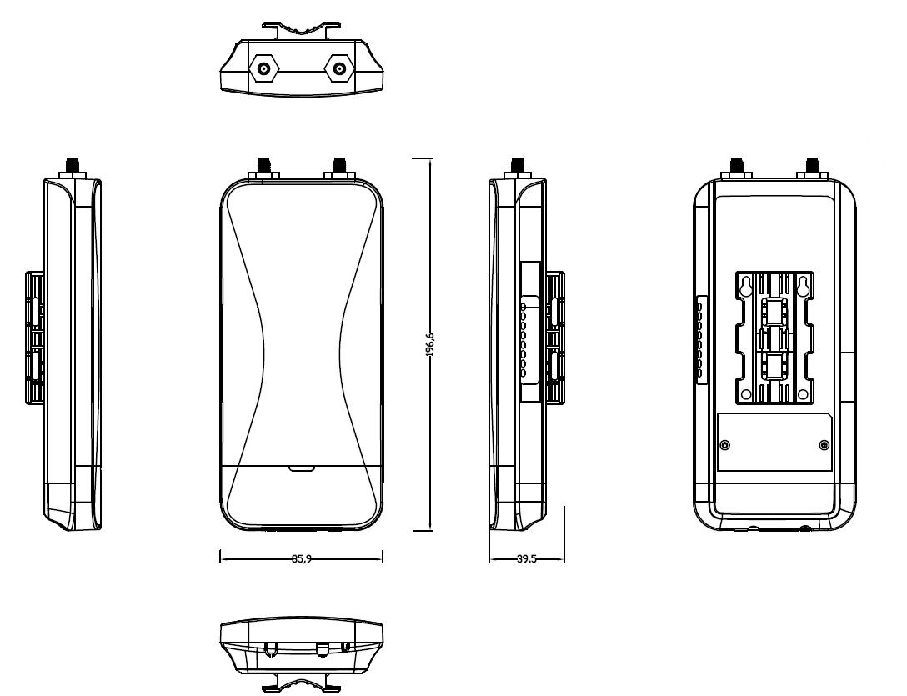

Packing List:

GNT-AP1200GF | 1
LAN cable | 1
Installation Accessory | 1
POE Adapter | 1
Antenna | 2

