11ax 3000Mbps Ceiling Wireless AP
Model: GNT-AP835F

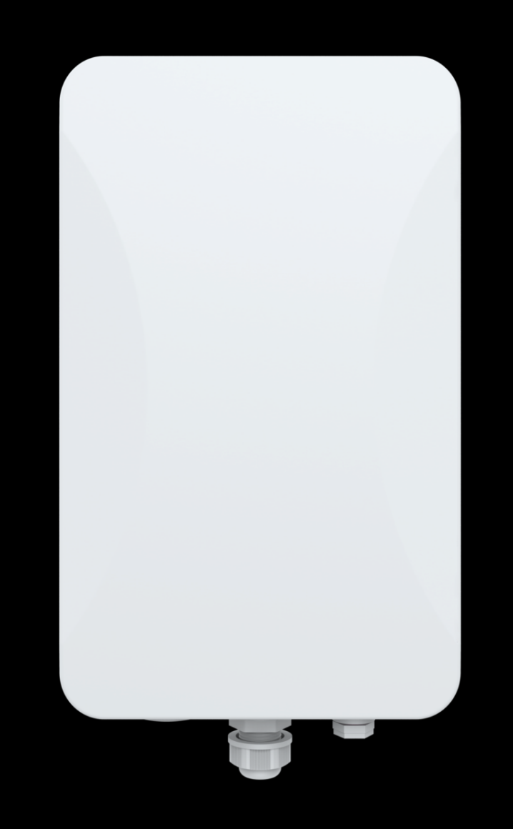
Short Specification
GNT-AP835F is a high-performance dual-band 802.11AX product that provides 2.4G and 5.8GHz dual-band wireless services. 2.4G provides a maximum access rate of 574Mbps, and 5G provides a maximum access rate of 2402Mbps.

Main Features:
- It has better transmission quality and higher transmission rate. The concurrent rate of the whole machine can reach up to 3000Mbps.
- Support hardware watchdog function, automatic recovery of abnormal equipment, maintenance-free.
- Elegant appearance design, hidden port housing, beautiful wiring.
- The addition of lightning protection board components greatly enhances the protection capability of the equipment.

Hardware Specification
Model | GNT-AP835F
CPU | MT7981B+MT7976DA+GPY211
Flash | SPI NOR 16MB
DDR3 | 256M
2.4G Frequency | 2.4GHz – 2.484GHz
2.4G Protocol | 802.11 b / g / n/ac /ax
5G Frequency | 5.150GHz～5.825GHz
5G Protocol | 802.11 a / n / ac /ax
Dual Band Antenna | 4*4dBi
Data Rate | 2.4G: 574Mbps; 5G: 2402Mbps
2.4G TX Power | 802.11b | 11M | 22±2dBm | 1M | 22±2dBm
2.4G TX Power | 802.11g | 54M | 19±2dBm | 6M | 21±2dBm
2.4G TX Power | 802.11n HT20 | MCS7 | 18±2dBm | MCS0 | 20±2dBm
2.4G TX Power | 802.11n HT40 | MCS7 | 18±2dBm | MCS0 | 20±2dBm
2.4G TX Power | 802.11ax HT20 | MCS11 | 16±2dBm | MCS0 | 20±2dBm
2.4G TX Power | 802.11ax HT40 | MCS11 | 16±2dBm | MCS0 | 20±2dBm
5G TX Power | 802.11a | 54M | 19±2dBm | 6M | 21±2dBm
5G TX Power | 802.11n HT20 | MCS7 | 18±2dBm | MCS0 | 20±2dBm
5G TX Power | 802.11n HT40 | MCS7 | 18±2dBm | MCS0 | 20±2dBm
5G TX Power | 802.11ac HT20 | MCS7 | 17±2dBm | MCS0 | 20±2dBm
5G TX Power | 802.11ac HT40 | MCS7 | 17±2dBm | MCS0 | 20±2dBm
5G TX Power | 802.11ac HT80 | MCS9 | 17±2dBm | MCS0 | 19±2dBm
5G TX Power | 802.11ax HT20 | MCS11 | 16±2dBm | MCS0 | 20±2dBm
5G TX Power | 802.11ax HT40 | MCS11 | 16±2dBm | MCS0 | 20±2dBm
5G TX Power | 802.11ax HT80 | MCS11 | 16±2dBm | MCS0 | 19±2dBm
5G TX Power | 802.11ax HT160 | MCS11 | 14±2dBm | MCS0 | 18±2dBm
2.4G Receiving Sensitivity | 802.11b | 11M | -87dBm | 1M | -96dBm
2.4G Receiving Sensitivity | 802.11g | 54M | -75dBm | 6M | -93dBm
2.4G Receiving Sensitivity | 802.11n HT20 | MCS7 | -73dBm | MCS0 | -92dBm

 | 802.11n HT40 | MCS7 | -70dBm | MCS0 | -89dBm
 | 802.11ax HT20 | MCS11 | -64dBm | MCS0 | -92dBm
 | 802.11ax HT40 | MCS11 | -61dBm | MCS0 | -89dBm
5G Receiving Sensitivity | 802.11a | 54M | -74dBm | 6M | -92dBm
5G Receiving Sensitivity | 802.11n HT20 | MCS7 | -73dBm | MCS0 | -90dBm
5G Receiving Sensitivity | 802.11n HT40 | MCS7 | -70dBm | MCS0 | -87dBm
5G Receiving Sensitivity | 802.11ac HT20 | MCS7 | -67dBm | MCS0 | -91dBm
5G Receiving Sensitivity | 802.11ac HT40 | MCS7 | -63dBm | MCS0 | -88dBm
5G Receiving Sensitivity | 802.11ac HT80 | MCS9 | -60dBm | MCS0 | -84dBm
5G Receiving Sensitivity | 802.11ax HT20 | MCS11 | -62dBm | MCS0 | -91dBm
5G Receiving Sensitivity | 802.11ax HT40 | MCS11 | -59dBm | MCS0 | -89dBm
5G Receiving Sensitivity | 802.11ax HT80 | MCS11 | -56dBm | MCS0 | -86dBm
5G Receiving Sensitivity | 802.11ax HT160 | MCS11 | -53dBm | MCS0 | -83dBm
2.4G EVM | 802.11b:≤-10 dB；802.11g:≤-25 dB；802.11n:≤-28dB ; 802.11ax: ≤-35 dB
5G EVM | 802.11a:≤-25 dB； 802.11n:≤-28 dB；802.11ac:≤-32 dB ; 802.11ax:≤-35 dB
ppm | ±20ppm
WAN | 1*10/100/1000/2500Mbps WAN, support 48V PoE
LAN | 1*10/100/1000Mbps LAN
Reset | Reset to factory settings by pressing 6-10 seconds
Indicators | PWR, SYS, WAN, 2.4G, 5.8G
Power | PoE 802.3at
Max Power Consumption | <18W
Dimension | 304mm×181mm×88mm
Weight | 1.6kg
Temperature | Working: -20°C to 55°C；Storage: -40°C to 70°C；Humidity: 5％～95％(Non-Condensing)
ESD | Air:±8K, Touch:±6K
Electrical Surge | Common Mode: 4K, Differential Mode: 2K

Firmware Specification
Working Mode | Gateway, AP
Wireless Functions | Multiple SSID functions: 2.4GHz: 4; 5.8GHz: 4.
Wireless Functions | Support SSID hidden
Wireless Functions | Support seamless roaming
Wireless Functions | Support 5G Prior for a faster Ethernet.
Wireless Functions | Wireless Security: Open, WPA, WPA2PSK_TKIPAES, WAP2_EAP, WPA3
Wireless Functions | Support MAC filter
Wireless Functions | Support Wi-Fi time on/off to save energy
Wireless Functions | Support client isolation to improve the wireless stability
Wireless Functions | Support RF power adjustable, adjust the RF power based on environment.
Networking Function | VLAN settings
Networking Function | Cloud access support in gateway mode
Device Management | Back-up the configuration
Device Management | Restore the configuration
Device Management | Reset to factory default
Device Management | Reboot the device: including time reboot or reboot immediately
Device Management | Admin management password modify
Device Management | Firmware upgrade
Device Management | System log
Device Management | Support firmware GUI web management, AC controller management, remote management and cloud management
Protocols | IPv4

Interface

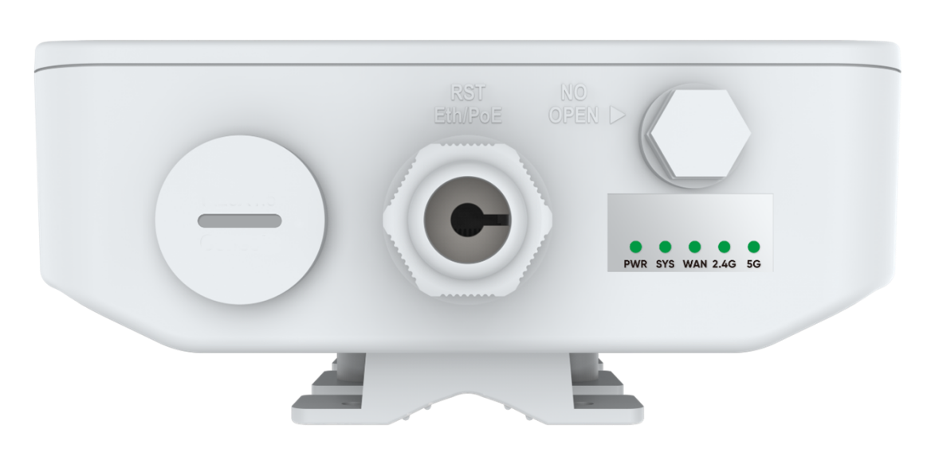

Dimension
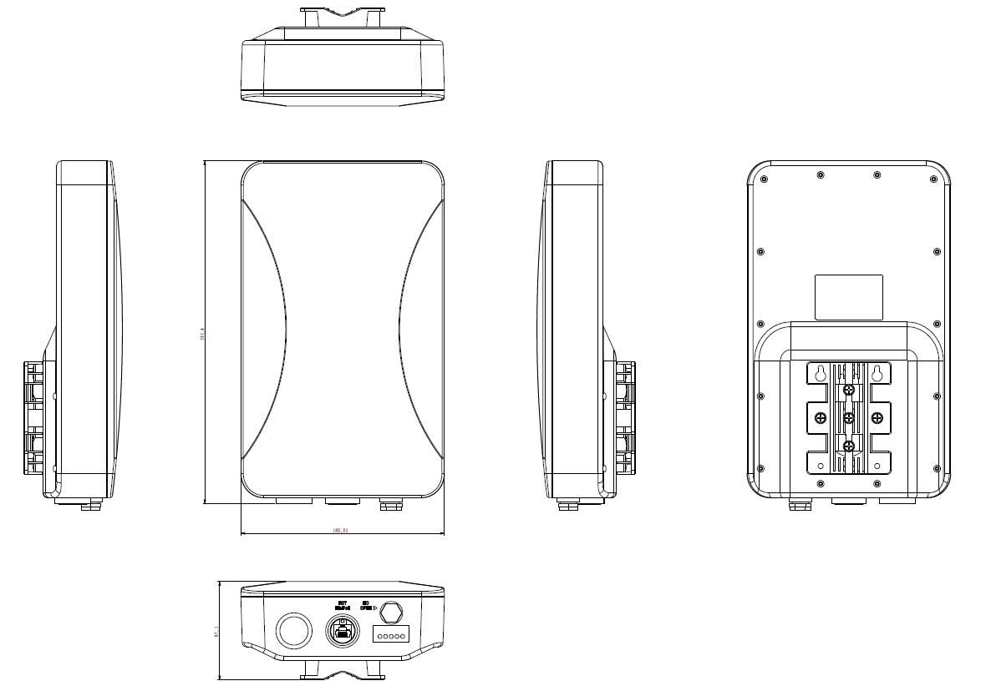

Packing List
AP | 1
Lan cable | 1
Mounting Accessories | 1
Gift Box | 1

