Enterprise Gateway & WLAN Controller
Model:GNT-AC220

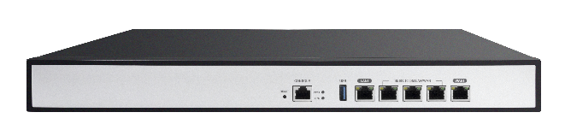

Short Specification:
GNT-AC220 is a large and medium-sized enterprise-level gateway based on CAPWAP protocol.

Main Features:
- The product is configured with 1 Gigabit WAN port, (multiple WANs can be configured) with WAN port load balancing, multi-operator access, line backup, network overlay, policy routing and other multi-WAN features.
- Supports intelligent flow control, Internet behavior management, network firewall, VPN settings, remote access control management and other functions.
- Allows a maximum of 256 end users to access, provides high-speed network, maximizes defense against network storms, and ensures normal network operations.
- It can be used as the main router in the network or as a bypass AC. It can manage and configure 256 APs. It can also be remotely managed and maintained in the future. Even in different cities and different networks, administrators can monitor them at any time. , the main page for managing and configuring GNT-AC220. The product has the characteristics of high performance, easy installation, and easy maintenance, which greatly saves manpower and material costs in network layout.

Hardware Spec:
Model | GNT-AC220
CPU | MT7621AT
DDR3L | 512M
Flash | 16M
Heat Dissipation | Natural heat dissipation
Interface | 4*Gigabit LAN (3 can be configured to multi WAN)
Interface | 1*Gigabit WAN
Interface | 1*Console
Interface | 1*USB3.0
Power | DC：12V
Size | 440 *219 *44mm
Working Temperature | 0℃～50℃
Storage Temperature | -40℃～70℃
Working Humidity | 5%～97%RH (No condensation)

Firmware Spec:
AP management | Users: 256 max
AP management | APs: 256 pcs
AP management | Centralized and remote AP management
AP management | User status view
Smart flow control | One-click intelligent flow control
Smart flow control | Powerful multi-line diversion
Smart flow control | Auto apply priority
Load balance | Multi WAN, multi ISPs access
Load balance | Smart load balance
Load balance | Line backup
Load balance | Network speed stack
Load balance | Policy routing: based on source IP address, destination IP address, source MAC address, network interface, domain name, destination port, Internet interface, identity binding and other policies
Load balance | Protocol banding
Load balance | Online detection
Routing | Static routing
Behavior management | Fully block P2P software
Behavior management | P2P flow control and bandwidth allocation
Behavior management | File transfer and URL filtering
Behavior management | Comprehensive control of network behavior
Bandwidth Control | IP based
Bandwidth Control | Guarantee/limit bandwidth
Bandwidth Control | Time based
Bandwidth Control | IP-based session restriction

Safety | MAC filter
Safety | URL filter
Safety | Web filter
Safety | IP filter
Safety | Port forwarding
Safety | DMZ
Defense Center | TCP/UDP/ICMP flood attack;
Defense Center | Block TCP scan
Defense Center | Block PING WAN port
ARP detection | Send GARP package
ARP detection | WAN/LAN port ARP scan
ARP detection | IP-MAC band
Authentication | Member, One-key, SMS, 3rd Party radius
Management | Web/CLI/Telnet
Management | Remote management
Others | DDNS, VPN

Dimension
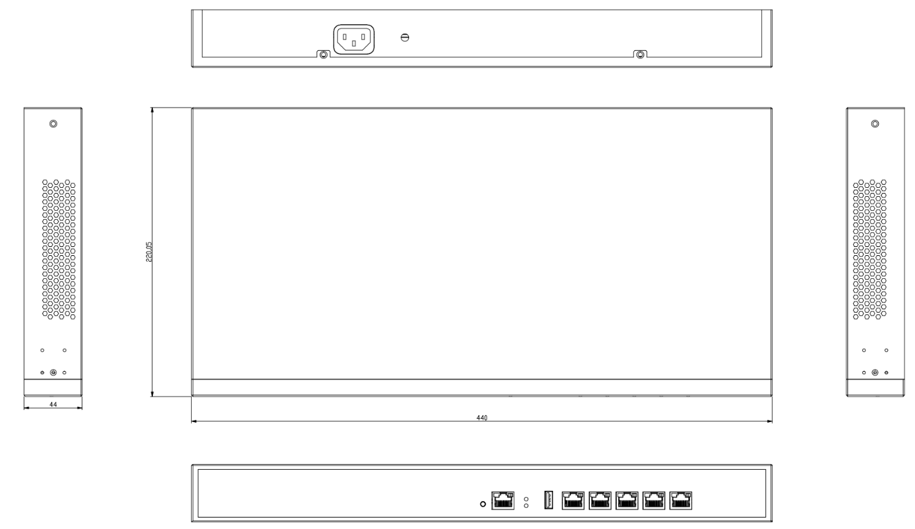

Packing List
Controller | 1
Power Supply | 1
Ethernet cable | 1
Accessory box | 1*(rack kits, pads, screws)

